Chester County - 2021 Reassessment Update
Chester County has scheduled reassessment for 2021. Chester’s 5-year reassessment, scheduled for 2020, was postponed one year until the 2021 tax year. The date of value remains December 31, 2019.
Chester County will send every property owner an assessment notice indicating the new appraisal (value). The assessment notice looks like this [insert Link to Blank Assessment Notice]. The notice provides the Current Market Appraisal (1), Current Taxable Appraisal (2), and the Assessment Ratio (3).
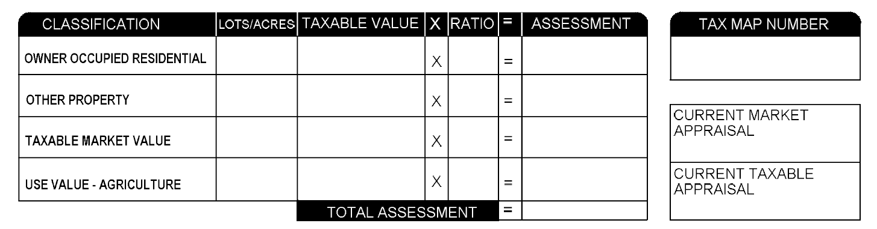
3
2
1

The property owner will have 90 days from the date of notice to request a review of the new assessment The Date of Notice (A) and 90 day deadline (B) will be printed on the form.
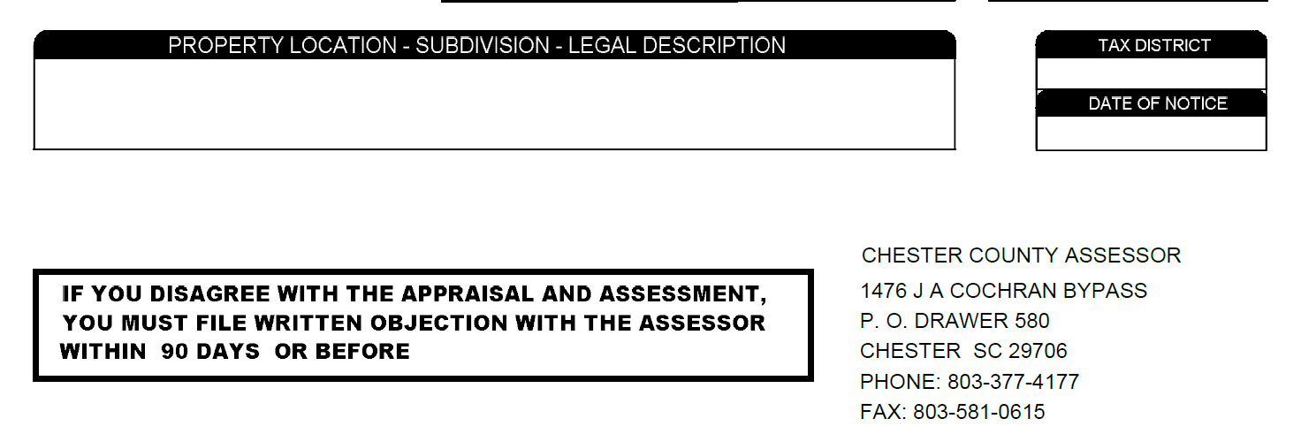
B
A

Request for review can be found on the Assessor’s section of the Forms page. (Link to Review Form]

Additional Information
Terms
- Assessment ratio. The percentage of your property value which is subject to taxation. Owner occupied legal residence are assessed at 4%. All other commercial property is assessed at 6%. Manufacturing property is assessed at 10.5%
  - Owner occupied legal residence [insert link to application link] receive statutory exemptions from portions of the tax.
- Current Market Appraisal (Value) Definition of Fair Market Value SC §12-37-930.
All property must be valued for taxation at its true value in money which in all cases is the price which the property would bring following reasonable exposure to the market, where both the seller and the buyer are willing, are not acting under compulsion, and are reasonably well informed of the uses and purposes for which it is adapted and for which it is capable of being used.

- Current Taxable Appraisal (Value) Increase in the value of real property at reassessment is limited to 15% if there are no other changes (additions, ATI, other). The taxable value is the value prior to reassessment times 1.15%, also called the “cap value”. Increases are “capped” at 15% over the prior assessment.

- Agricultural property is assessed at use value. [insert link to L[insert LNK TO Use application]

Example Calculation
The Current market value x the assessment ratio is the assessed value. When you multiple the assessed by the millage rate you get the tax due.
- Example of assessment
$100,000 taxable appraisal x 6% assessment ratio = $6,000
Millage rate = 400 mils. County Council and School Board set the county millage rate. The municipalities set the city rates.
Tax Calculation = $6,000 x 0.400 = $2,400 This is the Gross Tax . *
- Example of Cap value
Prior value $100,000. New appraisal for 2021 (Current Market Value) is $125,000. The Current Taxable Value is $115,000 (#100,000 x 1.15%)
The 2020 millage rates can be found on here for estimation purposes. The County Council and School Board set the county/school millage rates. The municipalities set the city rates. The 2021 millage rates have not yet been set.
* Owners that qualify for legal residence and/or the homestead refund will deduct the amount to estimate the Net Tax due.

